SEPTEMBER 2023 newsletter
St. Paul’’s & Buffalo Lutheran Churches

A Note from the Pastor

Ba de ya - say do you remember
Ba de ya - dancing in September
Ba de ya - golden dreams were shiny days

Allee Willis, Maurice White, Al Mckay; Earth, Wind, and Fire
September was a thirty-days long goodbye to summer, to the season that left everybody both happy and weary of the warm, humid weather and the exhausting but thrilling adventures.” – Lea Malot

“By all these lovely tokens, September days are here. With summer’s best of weather and autumn’s best of cheer.” – Helen Hunt Jackson

The calendar is full of new beginnings, the most obvious being the new calendar year that begins on January 1st. The new beginning that I think effects all of us more profoundly is September. Summer is over, vacations have been taken, and we hear that phrase that young people face with ambivalence and trepidation, and their parents hear with joy and excitement; back to school! September is the time when we resume our programing at church, especially Christian Education, and attendance at worship increases (we hope.) I look forward to seeing some of you that I have not met. Please join us for worship!

And let us consider how we may spur one another on toward love and good deeds, not giving up meeting together, as some are in the habit of doing, but encouraging one another—and all the more as you see the Day approaching. Hebrews 10:24-25

Pastor Allen

Cares and Concerns and Activities
SEPTEMBER SUNDAY WORSHIP SERVICES WILL BE HELD AT 9:00 AM AT ST PAUL’S LUTHERAN CHURCH. PASTOR ALLEN CAMPBELL CAN BE CONTACTED BY PHONE AT 507-828-0272. HE WILL APPRECIATE BEING CONTACTED BY PHONE REGARDING ANY SPECIAL EVENTS SUCH AS BAPTISMS OR FUNERALS! IF YOU CAN’T REACH HIM CONTACT CAROL HINTZ, OUR SECRETARY, BY LEAVING A MESSAGE ON ST. PAUL’S LUTHERAN CHURCH’S PHONE AT 749-2309 OR CALLING CAROL AT HER HOME AT 701-429-0030 AND THOSE IMPORTANT MESSAGES WILL BE FORWARDED TO PASTOR ALLEN AS SOON AS POSSIBLE

The Church Office should be open on Fridays from 1 PM-3 PM. If you find you need something at a different time don’t hesitate to call Carol at her home at 701-429-0030.

Our Saviors Lutheran Church, Page will be having services beginning Wednesday September 6 – Wednesday School 5:45 – 6:20 p.m. and Wednesday Worship – 6:30 p.m.

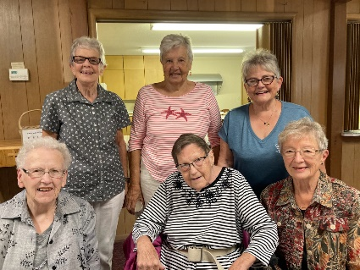
Naomi Circle was surprised to have a visit from their former member Lois Smith on August 27. She now resides in Bismarck.

Lennon Skye Smith will be baptized at St Paul’s Lutheran on September 24. She is the daughter of Tyler Smith and Tristen Prosser.

St. Paul’s Update

Feed My Starving Children
The Eastern North Dakota Synod is helping this organization through the use of monetary donations and help in filling the meals for hungry children around the world. Work hours are two hours long and the cost of the food filled during that time is $63. Can you help with a donation of time or money to help the cause?

Fill the Game Chest
Our hope is to occasionally open our church basement to school age children for non-electronic activities after school. We have a couple larger games and are in need of new/gently used/donations to fill our games cabinet with activities for the kids. We are also looking for snack donations during these activities.

Vacation Bible School
Thank you to everyone who helped make this summer’s week a huge success. We had an engaging week of learning, doing, and playing. The finale was a potluck picnic in the park followed by the entertaining play “Noah’s Cruise” and songs.
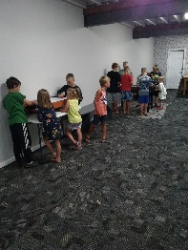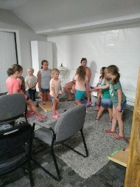

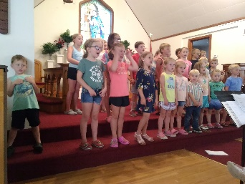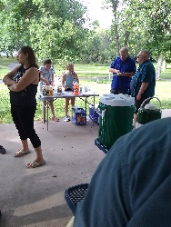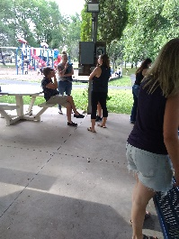
Carpet at St. Paul’s
To help complete the work already started at the church, money has been donated to purchase and install carpet on the three step areas in the church. The sanctuary carpet is also over 50 years old and should be replaced. If you would like to donate towards this project, contact the church office or a council member.

Church Basement Remodel
The church basement has undergone a full remodel and is completed except for the window framing. We have used the new area for funeral family space and VBS. If you have more ideas, please, let us know.

Church Exterior
The south door has been replaced and we are still waiting for the siding company to fulfill their contractual obligation to resurface the south and west siding. Their excuse has been that they cannot access the siding above the west entry.

Balcony
The balcony has been cleaned and walls painted to accent the stained glass window. The stairwell walls leading to the balcony are in need of repair.

Youth Education
Rally Sunday is scheduled for September 17 and Sunday School will be held from 10:00-10:30 following church services. Confirmation for grades 7-8 will be held Wednesday evenings. Please, text Carol at splbl@ictc.com with the names and ages of participants.

Shirley Anderson, St. Paul’s President

